This is explanation of the framework.

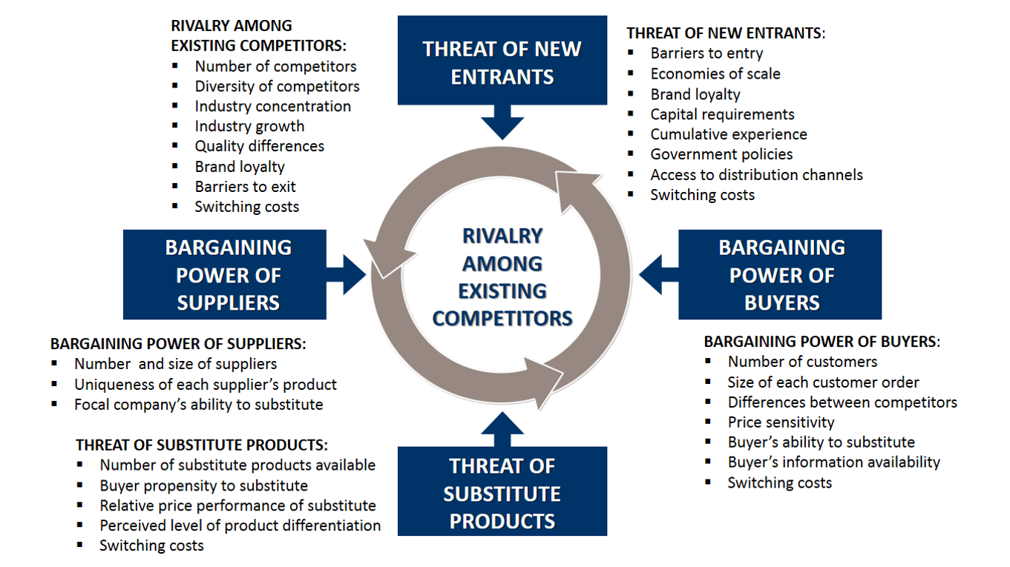

This is explanation of the framework.